**LAB # 08**

**Task # 01:** Create a payroll system using **classes**, **inheritance** and **polymorphism**

Four types of employees paid weekly

1. **Salaried employees**: fixed salary irrespective of hours
2. **Hourly employees**: 40 hours salary and overtime (> 40 hours)
3. **Commission employees**: paid by a percentage of sales
4. **Base-plus-commission employees**: base salary and a percentage of sales

The information know about each employee is his/her first name, last name and national identity card number. The reset depends on the type of employee.

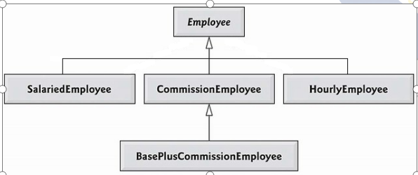

**Solution:**

**CLASS EMPLOYEE**

public class employee {

String firstname;

String lastname;

String cnic;

public employee() {}

public employee(String firstname, String lastname, String cnic) {

this.firstname = firstname;

this.lastname = lastname;

this.cnic = cnic;}

public void setCnic(String cnic) {

this.cnic = cnic;}

public void setFirstname(String firstname) {

this.firstname = firstname;}

public void setLastname(String lastname) {

this.lastname = lastname;}

public String getFirstname() {

return firstname;}

public String getLastname() {

return lastname;}

public String getCnic() {

return cnic;}

@Override

public String toString(){

return ("\nFirst Name : "+ firstname+"\n "+"Last Name : "+lastname+"\n"+"CNIC : "+cnic+"\n ");}

double earning(){

return 0.0;}

**CLASS SALARIED EMPLOYEE**

public class SalariedEmployee extends employee{

private double weeklysalary;

public void setWeeklysalary(double weeklysalary) {

if (weeklysalary>=0) {

this.weeklysalary = weeklysalary;

}else{

System.out.println("Salary Cn't Be Negative !!");

}}

public SalariedEmployee(double weeklysalary) {

this.weeklysalary = weeklysalary;}

public SalariedEmployee() {}

public SalariedEmployee(String firstname, String lastname, String cnic,double weeklySalary) {

super( firstname, lastname, cnic);

this.weeklysalary=weeklySalary; }

@Override

public String toString() {

return "\n "+"Weekly Salary : "+weeklysalary+"\n"+super.toString(); }

@Override

double earning() {

return weeklysalary; }}

**CLASS HOURLY EMPLOYEE**

public class HourlyEmployee extends employee {

double wage;

double hour;

public void setWage(double wage) {

if (wage >= 0) {

this.wage = wage;

} else {

System.out.println("WAGE Can't Be Negative !!");

}}

public void setHour(double hour) {

if (hour >= 0) {

this.hour = hour;

} else {

System.out.println("HOUR Can't Be Negative !!");

}}

public HourlyEmployee() {}

public HourlyEmployee(String firstname, String lastname, String cnic, double wage, double hour) {

super(firstname, lastname, cnic);

this.wage = wage;

this.hour = hour; }

@Override

public String toString() {

return "HOURLY EMPLOYEE " + "\n " + super.toString();}

@Override

double earning() {

if (hour <= 40) {

return wage * hour;

} else {

return 40 * wage + (hour - 40) * wage * 1.5;

}}}

**CLASS COMMISSION EMPLOYEE**

public class CommissionEmployee extends employee{

double grossSales ;

double commissionRate ;

public void setGrossSales(double grossSales) {

if (grossSales >= 0) {

this.grossSales = grossSales;

} else {

System.out.println("Gross Sales Can't Be Negative !!");}}

public void setCommissionRate(double commissionRate) {

if (commissionRate >= 0) {

this.commissionRate = commissionRate;

} else {

System.out.println("Commission Rates Can't Be Negative !!");

}}

public CommissionEmployee() {}

public CommissionEmployee(double grossSales, double commissionRate,String firstname, String lastname, String cnic) {

super(firstname, lastname, cnic);

this.grossSales = grossSales;

this.commissionRate = commissionRate;}

@Override

public String toString() {

return "\nCommission Employee: "+super.toString(); }

@Override

double earning() {

return grossSales * commissionRate;}

**CLASS BASE PLUS COMMISSION EMPLOYEE**

public class BasePlusCommissionEmployee extends CommissionEmployee {

double basesalary;

public double getBasesalary() {

return basesalary;}

public void setBasesalary(double basesalary) {

if (basesalary >= 0) {

this.basesalary = basesalary;

} else {

System.out.println("Base salary Can't Be Negative !!");}}

public BasePlusCommissionEmployee() {}

public BasePlusCommissionEmployee(String firstName, String lastName, String CNIC, double grossSale, double commissionRate, double basesalary) {

super(grossSale, commissionRate, firstName, lastName, CNIC);

this.basesalary = basesalary;}

@Override

public String toString() {

return "\nBase plus Commission employee: " + super.toString();}

@Override

double earning() {

return basesalary + super.earning();}}

**MAIN METHOD**

public class Polymorphism {

public static void main(String[] args) {

employee firstEmployee = new SalariedEmployee("AHSAN", "SAJJAD", "141-11-1261", 800.00);

employee secondEmployee = new CommissionEmployee(10000, 0.06, "ali", "anwar", "362-22-2252");

employee thirdEmployee = new BasePlusCommissionEmployee("akram", "nasim", "413-33-3453", 5000, 0.04, 300);

employee fourthEmployee = new HourlyEmployee("uzair", "ali", "9874-44-4444", 16.75, 40);

// polymorphism: calling toString() and earning() on Employee’s reference

System.out.println(firstEmployee);

System.out.println("Earning :" + firstEmployee.earning());

System.out.println(secondEmployee);

System.out.println("Earning :" + secondEmployee.earning());

System.out.println(thirdEmployee);

// performing downcasting to access & raise base salary

BasePlusCommissionEmployee currentEmployee

= (BasePlusCommissionEmployee) thirdEmployee;

double oldBaseSalary = currentEmployee.getBasesalary();

System.out.println("old base salary: " + oldBaseSalary);

currentEmployee.setBasesalary(1.10 * oldBaseSalary);

System.out.println("new base salary with 10% increase is:" + currentEmployee.getBasesalary());

System.out.println("Earning :" + thirdEmployee.earning());

System.out.println(fourthEmployee);

System.out.println("Earning :" + fourthEmployee.earning());}}

**Output:**

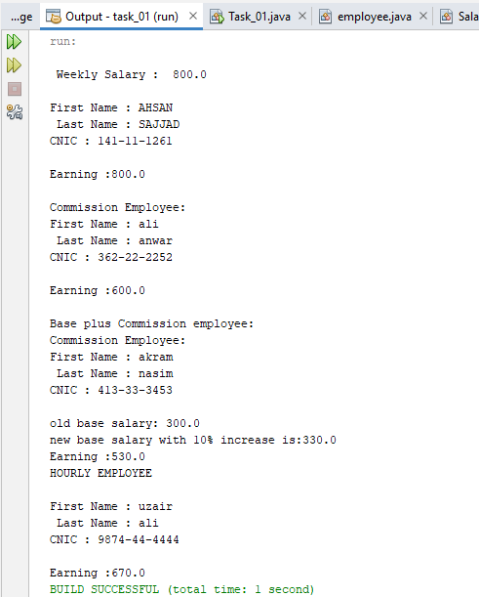

**Task # 02: You have to implement the following diagram including some attributes and other functions:**

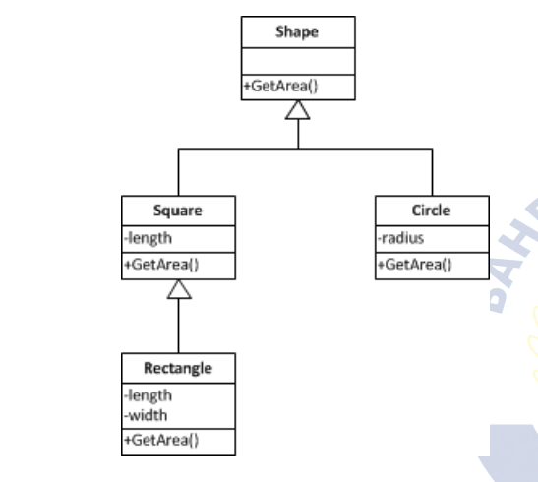

**Solution:**

**public static void main(String[] args) {**

char re;

do {

Scanner input = new Scanner(System.in);

Shape sh=new Shape();

sh.getArea();

System.out.print("\n 1) SQUARE\n2) Circle\n3) RECTANGLE\nENTER : ");

int res = input.nextInt();

switch (res) {

case 1:

Square s=new Square(4);

s.getArea();

break;

case 2:

Circle c=new Circle(5);

c.getArea();

break;

case 3:

Rectangle r=new Rectangle(4,5);

r.getArea();

break;

default:

System.out.println("INVALID ENTRY");

break;

}

System.out.print("Do you want to calculate more area: ");

re=input.next().toLowerCase().charAt(0);

} while (re=='y');

}

**public class Shape {**

public void getArea() {

System.out.println("SHAPES ARE GIVEN: ");

}

}

**public class Square extends Shape {**

private double length;

public Square() {

this.length = 0.0;

}

public Square(double length) {

this.length = length;

}

public double getLength() {

return length;

}

public void setLength(double length) {

this.length = length;

}

public double calcarea(){

return length*length;

}

public void getArea(){

System.out.println("the AREA of SQUARE: "+ calcarea());

}}

**public class Circle extends Shape {**

private double radius;

public Circle() {

this.radius = 0.0;

}

public Circle(double radius) {

this.radius = radius;

}

public double getRadius() {

return radius;

}

public void setRadius(double radius) {

this.radius = radius;

}

public double calcarea(){

return Math.PI*radius*radius;

}

public void getArea(){

System.out.println("the AREA of Circle: "+ calcarea());

}

}

**public class Rectangle extends Square{**

private double length,width;

public Rectangle(double length, double width) {

this.length=length;

this.width = width;

}

public double getLength() {

return length;

}

public void setLength(double length) {

this.length = length;

}

public double getWidth() {

return width;

}

public void setWidth(double width) {

this.width = width;

}

public double calcarea(){

return length*width;

}

public void getArea(){

System.out.println("the AREA of SQUARE: "+ calcarea());

}}

**Output:**

